Title of the Communication (Times 14pt, bold, centred)
…blank line…
First Author, Second Author, … and Last Author (times 12 pt, centred)

Full authors’ Addresses, one per line, including postal code (times 10 pt, italic, centred)
corresponding.author@email (times 10pt, centred)
…blank line…
I am applying for Bruker Customer Excellence Award (see Bruker Awards Guideline at eucmos2025.uwr.edu.pl)
Abstract text (full justified without paragraph indentation; single spacing). Font: times 12 pt. Please do not change “page set up” parameters of this document and keep margins as they are. Look carefully to the examples provided here and please use the same style of presentation.
Figures and Tables shall be centred in the page and numbered accordingly with their order of appearance in the text. Please avoid use of colour in the figures, since they will appear black and white (grey scale) in the final print out. The colour elements will only be visible in the electronic version of the abstract. Tables must be concise and prepared using font arial 10 pt.
The abstract (including figures, tables and references) must not exceed one page.
…blank line above figures…
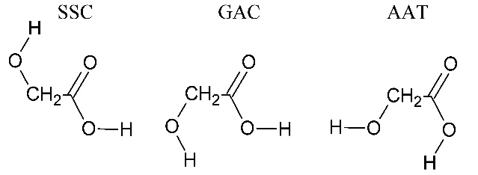
Figura 1 – Legend of the figure (times 10 pt, centred)
…blank line below figures…
References shall be numbered and appear at the end of abstract headed by the word “References”, as illustrated below.
Acknowledgements should appear at the end of the abstract, using the format specified below.
…blank line…

References
…blank line…
1. A. Author, B. Author, C. Author, J. Photochem. Photobiol., 2 (2024) 320.
2. Authors, Journal, Vol. (Year) 1st page.
…blank line…
Acknowledgements: The authors thank....

